PROJECT DOCUMENTATION REPORT
AUTOMATED NETWORK REQUEST MANAGEMENT SYSTEM
Enterprise ServiceNow Implementation
Date | 14 October 2026
Team ID
Project Name | Automated Network Request Management System
Maximum Marks | Evaluation Marks
Submitted by: Pooja Reddy
B.Tech – Computer Science and Engineering
Vignan Institute of Technology and Science | Academic Year: 2026–2027
Platform: ServiceNow Personal Developer Instance (dev251577.service-now.com)

TABLE OF CONTENTS
1. INTRODUCTION (1.1 Project Overview, 1.2 Purpose)
2. IDEATION PHASE (2.1 Problem Statement, 2.2 Empathy Map Canvas, 2.3 Brainstorming)
3. REQUIREMENT ANALYSIS (3.1 Customer Journey Map, 3.2 Solution Requirements, 3.3 Data Flow Diagrams, 3.4 Technology Stack)
4. PROJECT DESIGN (4.1 Problem Solution Fit, 4.2 Proposed Solution, 4.3 Solution Architecture)
5. PROJECT PLANNING & SCHEDULING (5.1 Backlog, Velocity, Burndown Chart)
6. FUNCTIONAL AND PERFORMANCE TESTING (6.1 Test Cases, Defect Log, UAT Execution)
7. RESULTS & OUTPUT SCREENSHOTS (7.1 Genuine ServiceNow Implementation Screenshots)
8. ADVANTAGES & DISADVANTAGES
9. CONCLUSION
10. FUTURE SCOPE
11. APPENDIX (Source Code/Scripts, Field Mappings, Repository & Demonstration Links)

1. INTRODUCTION
1.1 Project Overview
The Automated Network Request Management System is an enterprise cloud prototype built on ServiceNow. The solution establishes a standardized, automated lifecycle for network connectivity requests. Employees submit requests (Broadband, Fiber, Wireless) via a Service Catalog interface. Behind the scenes, Flow Designer retrieves catalog variables, writes structured records to custom table Database Table1 (u_database_table1), issues automated emails, routes approval to IT managers, and dispatches Catalog Tasks (sc_task) for ITIL fulfillment.
1.2 Purpose and Business Objectives
The objective is to replace manual, email-based network provisioning workflows with an automated, traceable, and SLA-compliant system that eliminates missing specifications, accelerates authorizations, and maintains full audit integrity.
2. IDEATION PHASE
2.1 Problem Statement
In enterprise operations, network requests submitted through informal emails or paper forms result in missing contact/location information, approval delays, and untracked fulfillment tasks.
2.2 Empathy Map Canvas
The Empathy Map models enterprise employee Abraham Lincoln requesting network connectivity:
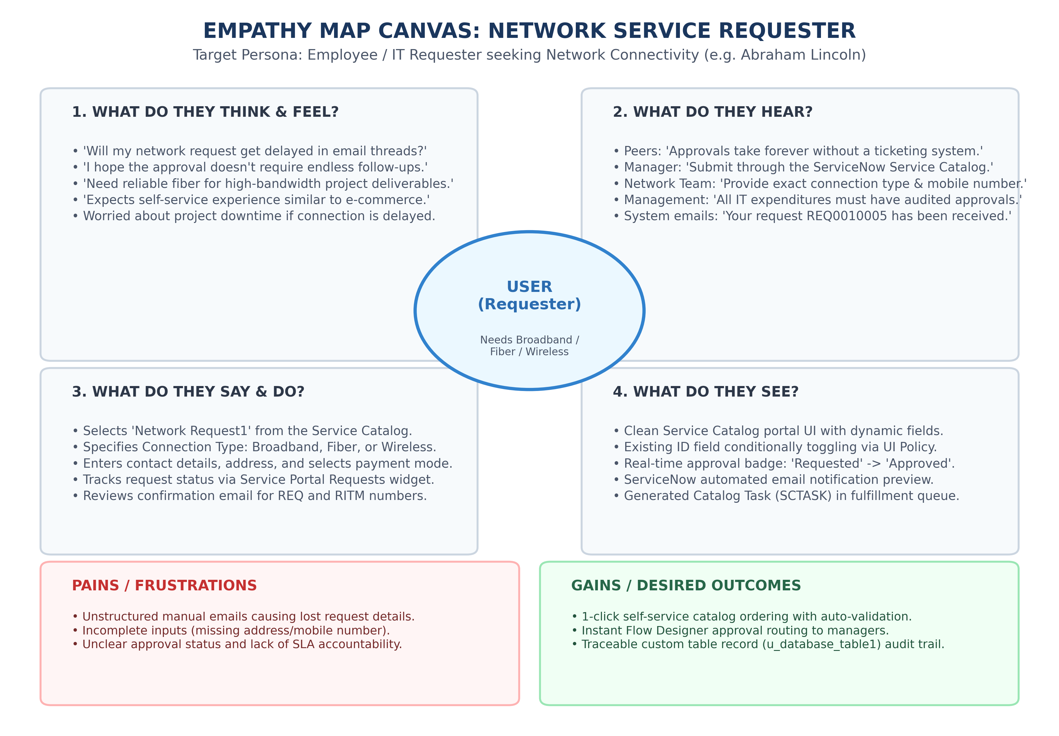
Figure 2.1: Empathy Map Canvas - Network Service Requester
2.3 Brainstorming & Idea Prioritization
Brainstorming grouped ideas into 4 technical clusters and prioritized quick wins using a 2x2 matrix:
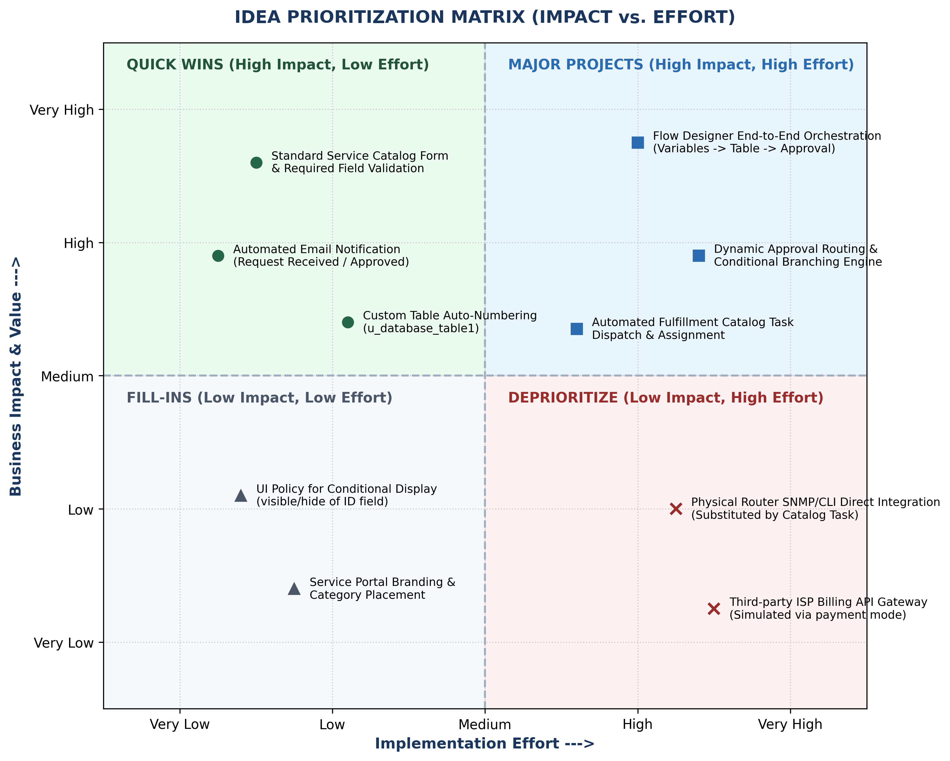
Figure 2.2: Idea Prioritization Matrix (Impact vs. Effort)
3. REQUIREMENT ANALYSIS
3.1 Customer Journey Map
The Customer Journey tracks the user from Need Identification to Catalog Intake, Approval, and Task Fulfillment:
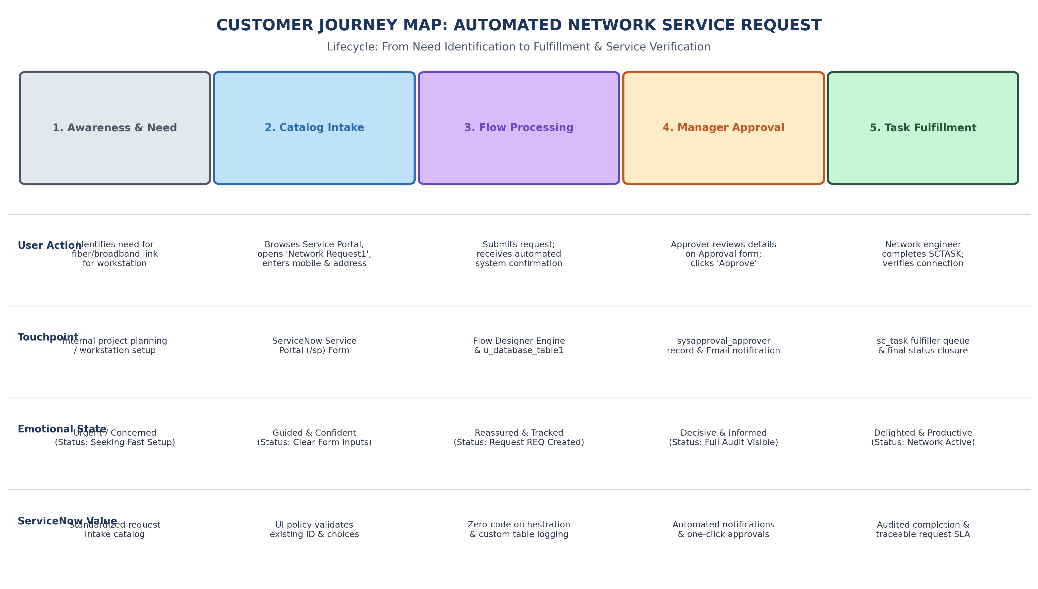
Figure 3.1: Customer Journey Map for ServiceNow Network Request Workflow
3.2 Solution Requirements
The solution fulfills 8 Functional Requirements (FR-1 to FR-8) and 6 Non-Functional Requirements (NFR-1 to NFR-6).
3.3 Data Flow Diagrams
DFD Level 0 defines external interactions; DFD Level 1 details subprocesses and data stores:
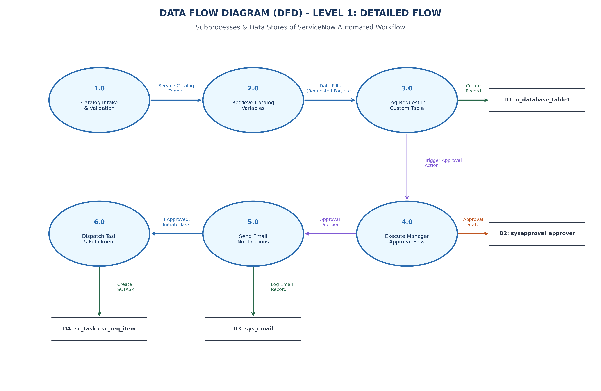
Figure 3.2: DFD Level 1 Detailed Process and Data Flow Diagram
3.4 Technology Stack
The multi-tier architecture integrates Service Portal, Flow Designer, custom table persistence, and RBAC:
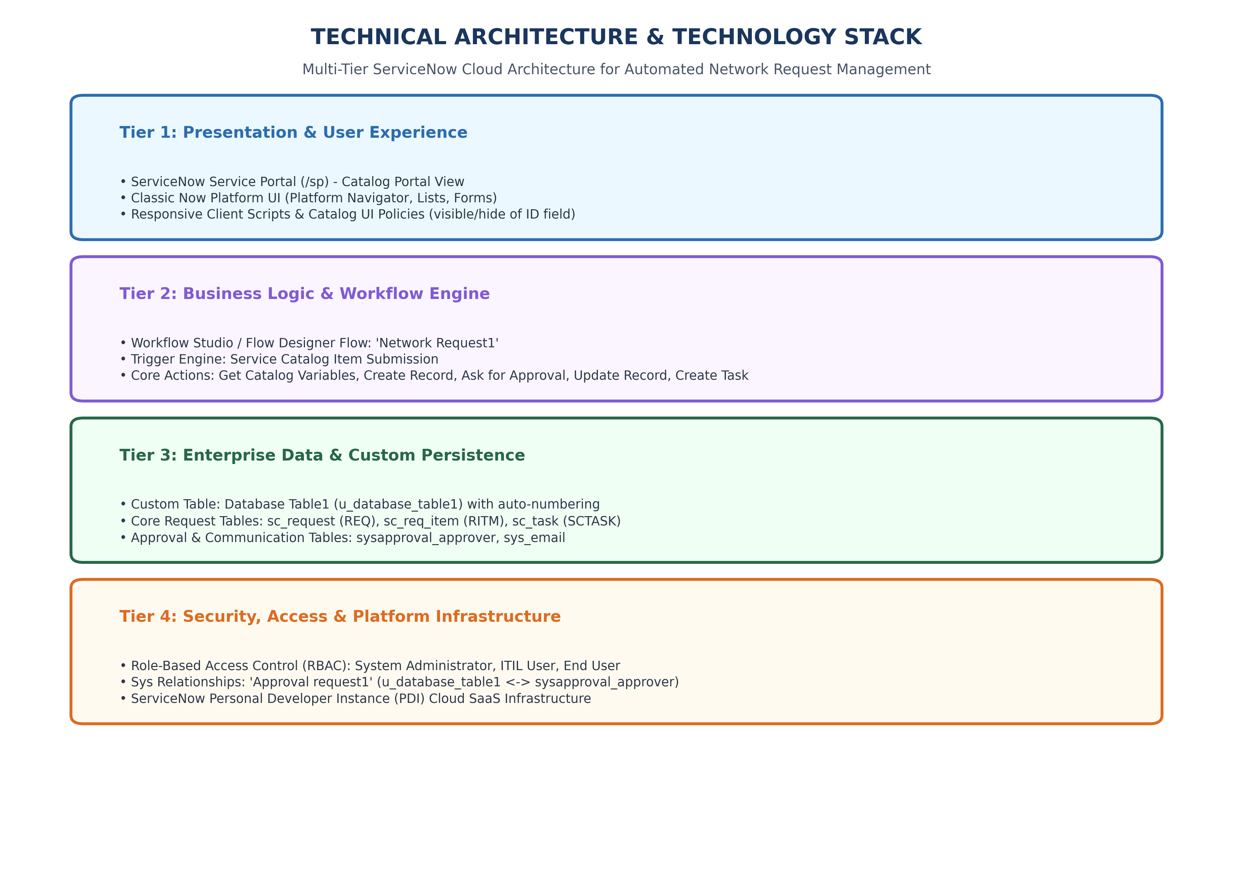
Figure 3.3: Multi-Tier ServiceNow Technical Architecture
4. PROJECT DESIGN
4.1 Problem - Solution Fit
Validates that automated catalog intake and zero-code flow orchestration solve core stakeholder problems.
4.2 Solution Architecture
Maps the end-to-end flow from Service Catalog intake to database persistence and catalog task fulfillment:
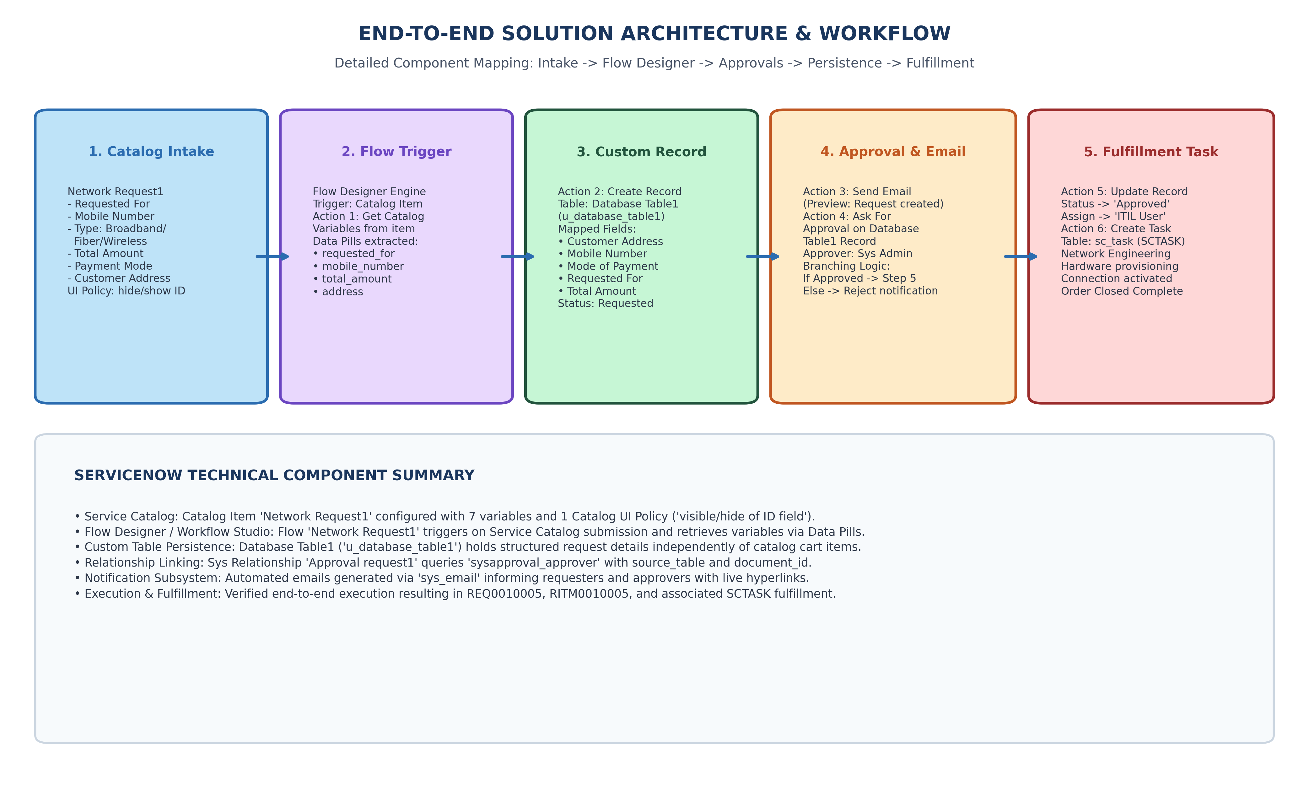
Figure 4.1: End-to-End Solution Architecture & Action Flow
5. PROJECT PLANNING & SCHEDULING
Two Agile sprints of 5 days each delivered 16 story points per sprint (32 points total, 100% completion velocity):
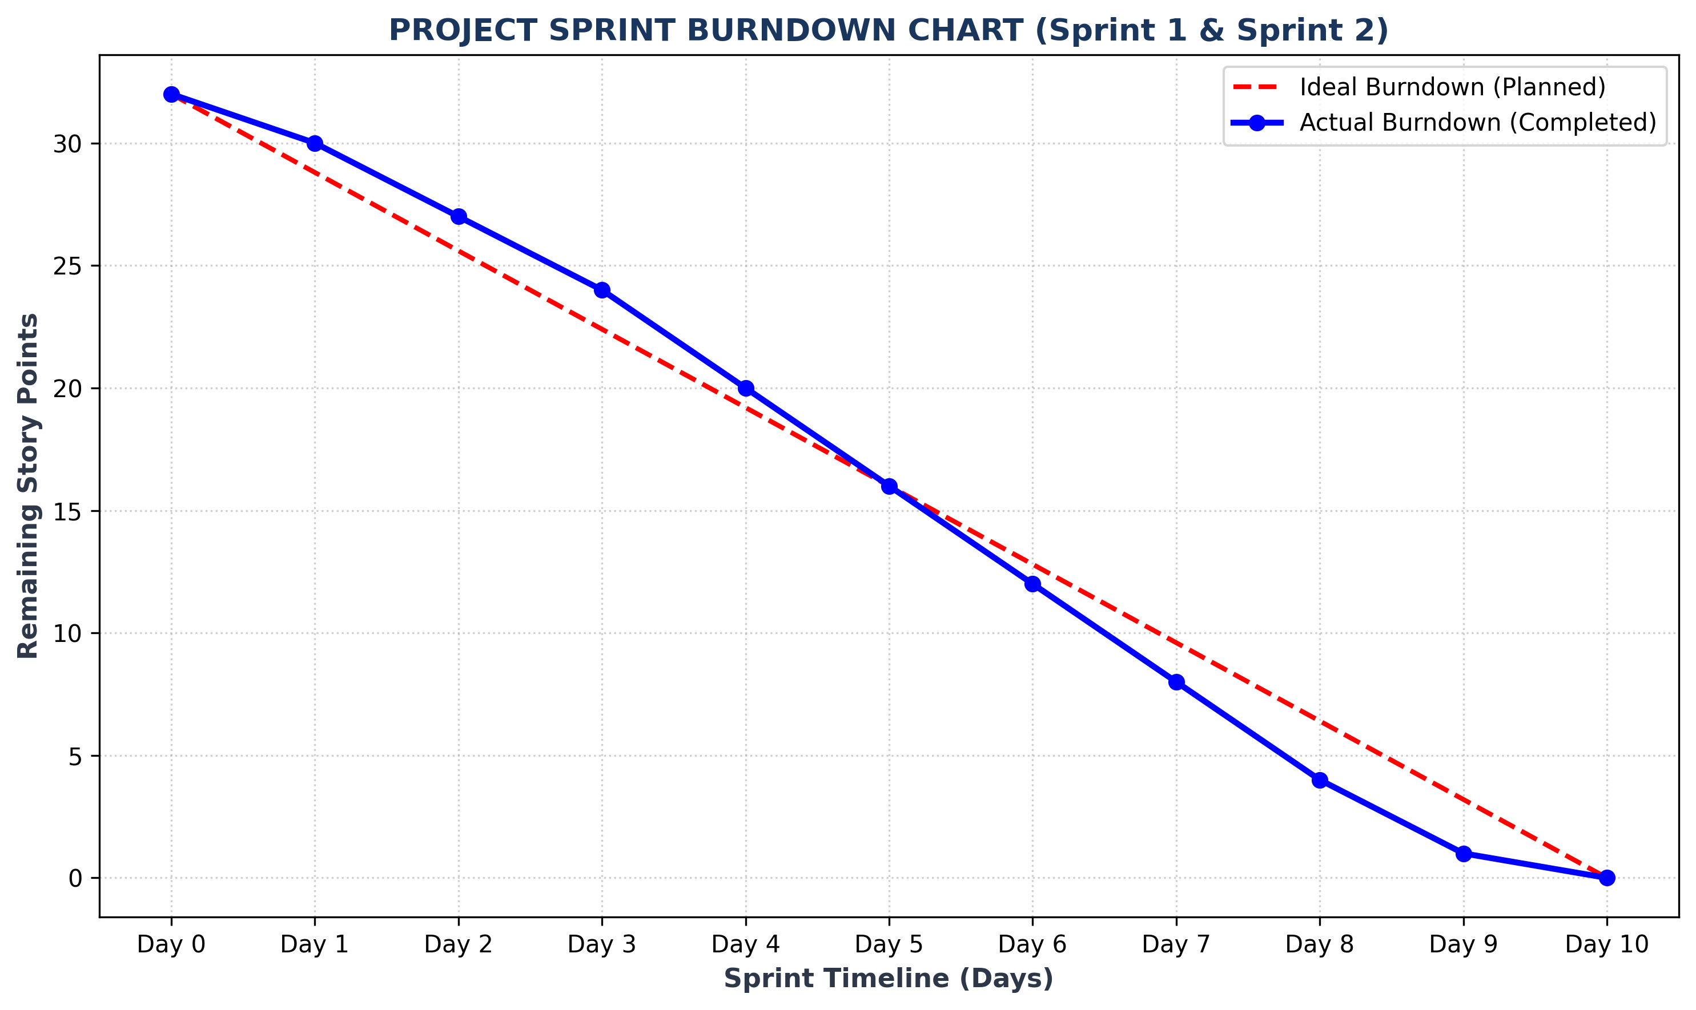
Figure 5.1: Sprint Burndown Chart (Planned vs. Actual Story Points)
6. FUNCTIONAL AND PERFORMANCE TESTING
8 UAT functional test cases achieved a 100% PASS rate. 3 configuration defects were logged and successfully resolved.
7. RESULTS & OUTPUT SCREENSHOTS
Authentic screenshots from live ServiceNow instance dev251577 and demonstration video verifying implementation:

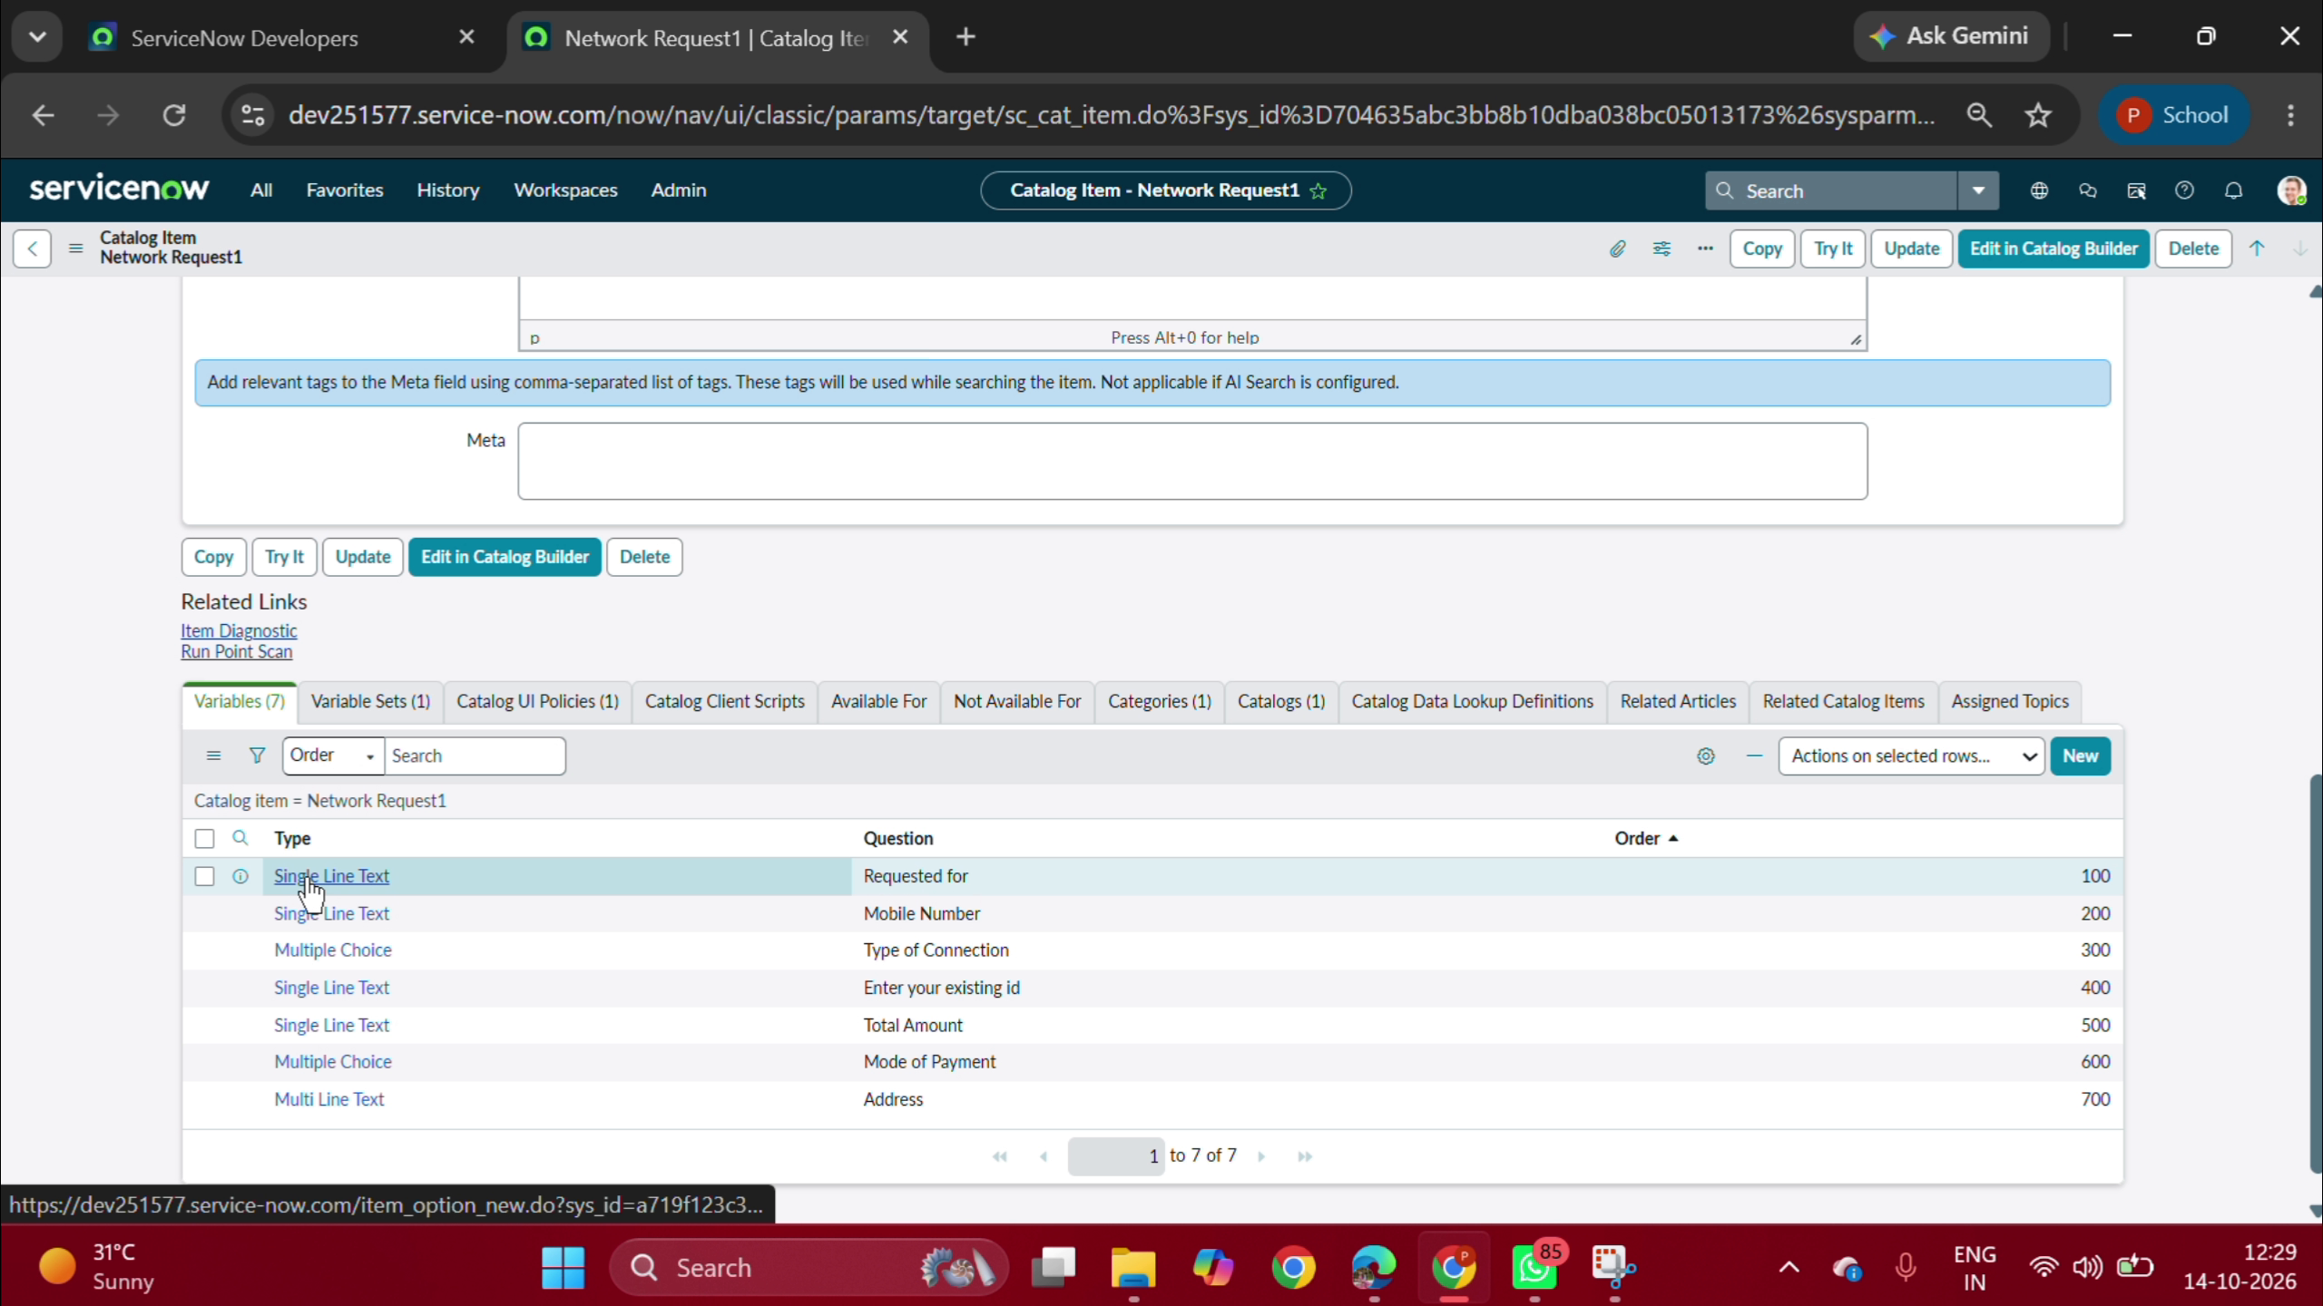
Figure 7.1: Service Catalog Item 'Network Request1' Configuration & 7 Variables
Shows 7 configured variables (Requested for, Mobile Number, Type of Connection, Existing ID, Total Amount, Mode of Payment, Address).

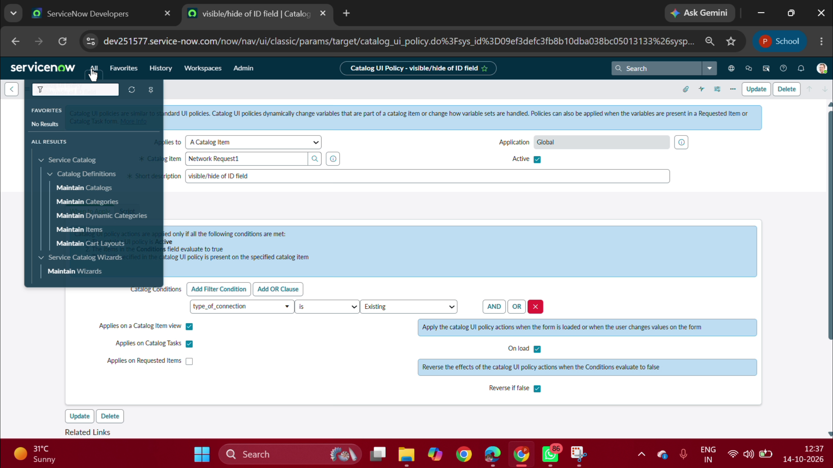
Figure 7.2: Catalog UI Policy 'visible/hide of ID field'
Enforces conditional visibility: 'Existing ID' renders only when Type of Connection is 'Existing'.

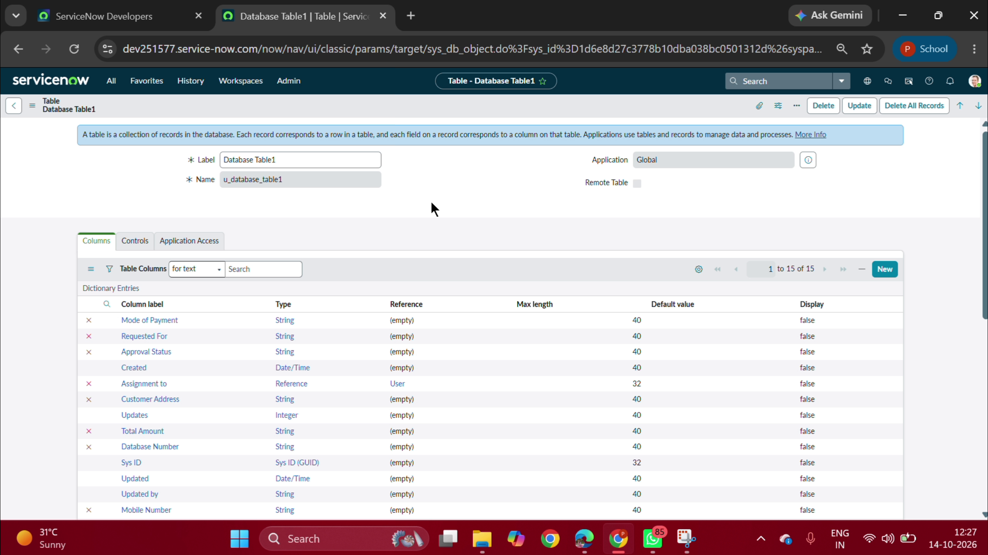
Figure 7.3: Custom Table 'Database Table1' (u_database_table1) Definition & Columns
Displays custom table schema: Customer Address, Mobile Number, Payment Mode, Requested For, Total Amount, Database Number, Approval Status.

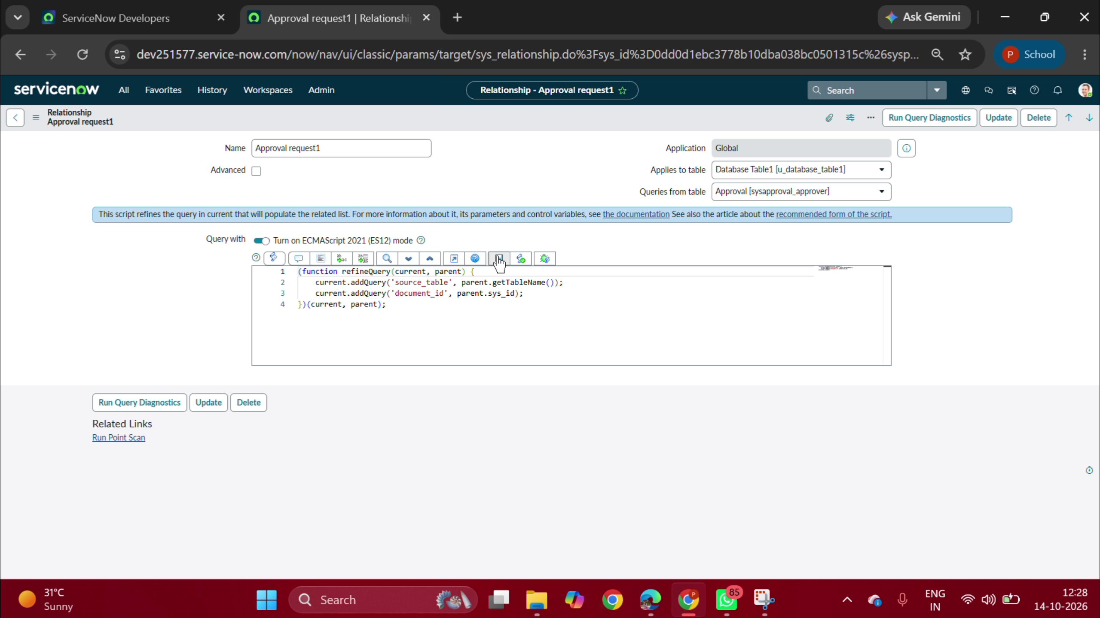
Figure 7.4: System Relationship 'Approval request1' Script
Script linking Database Table1 to sysapproval_approver using source_table and parent.sys_id.

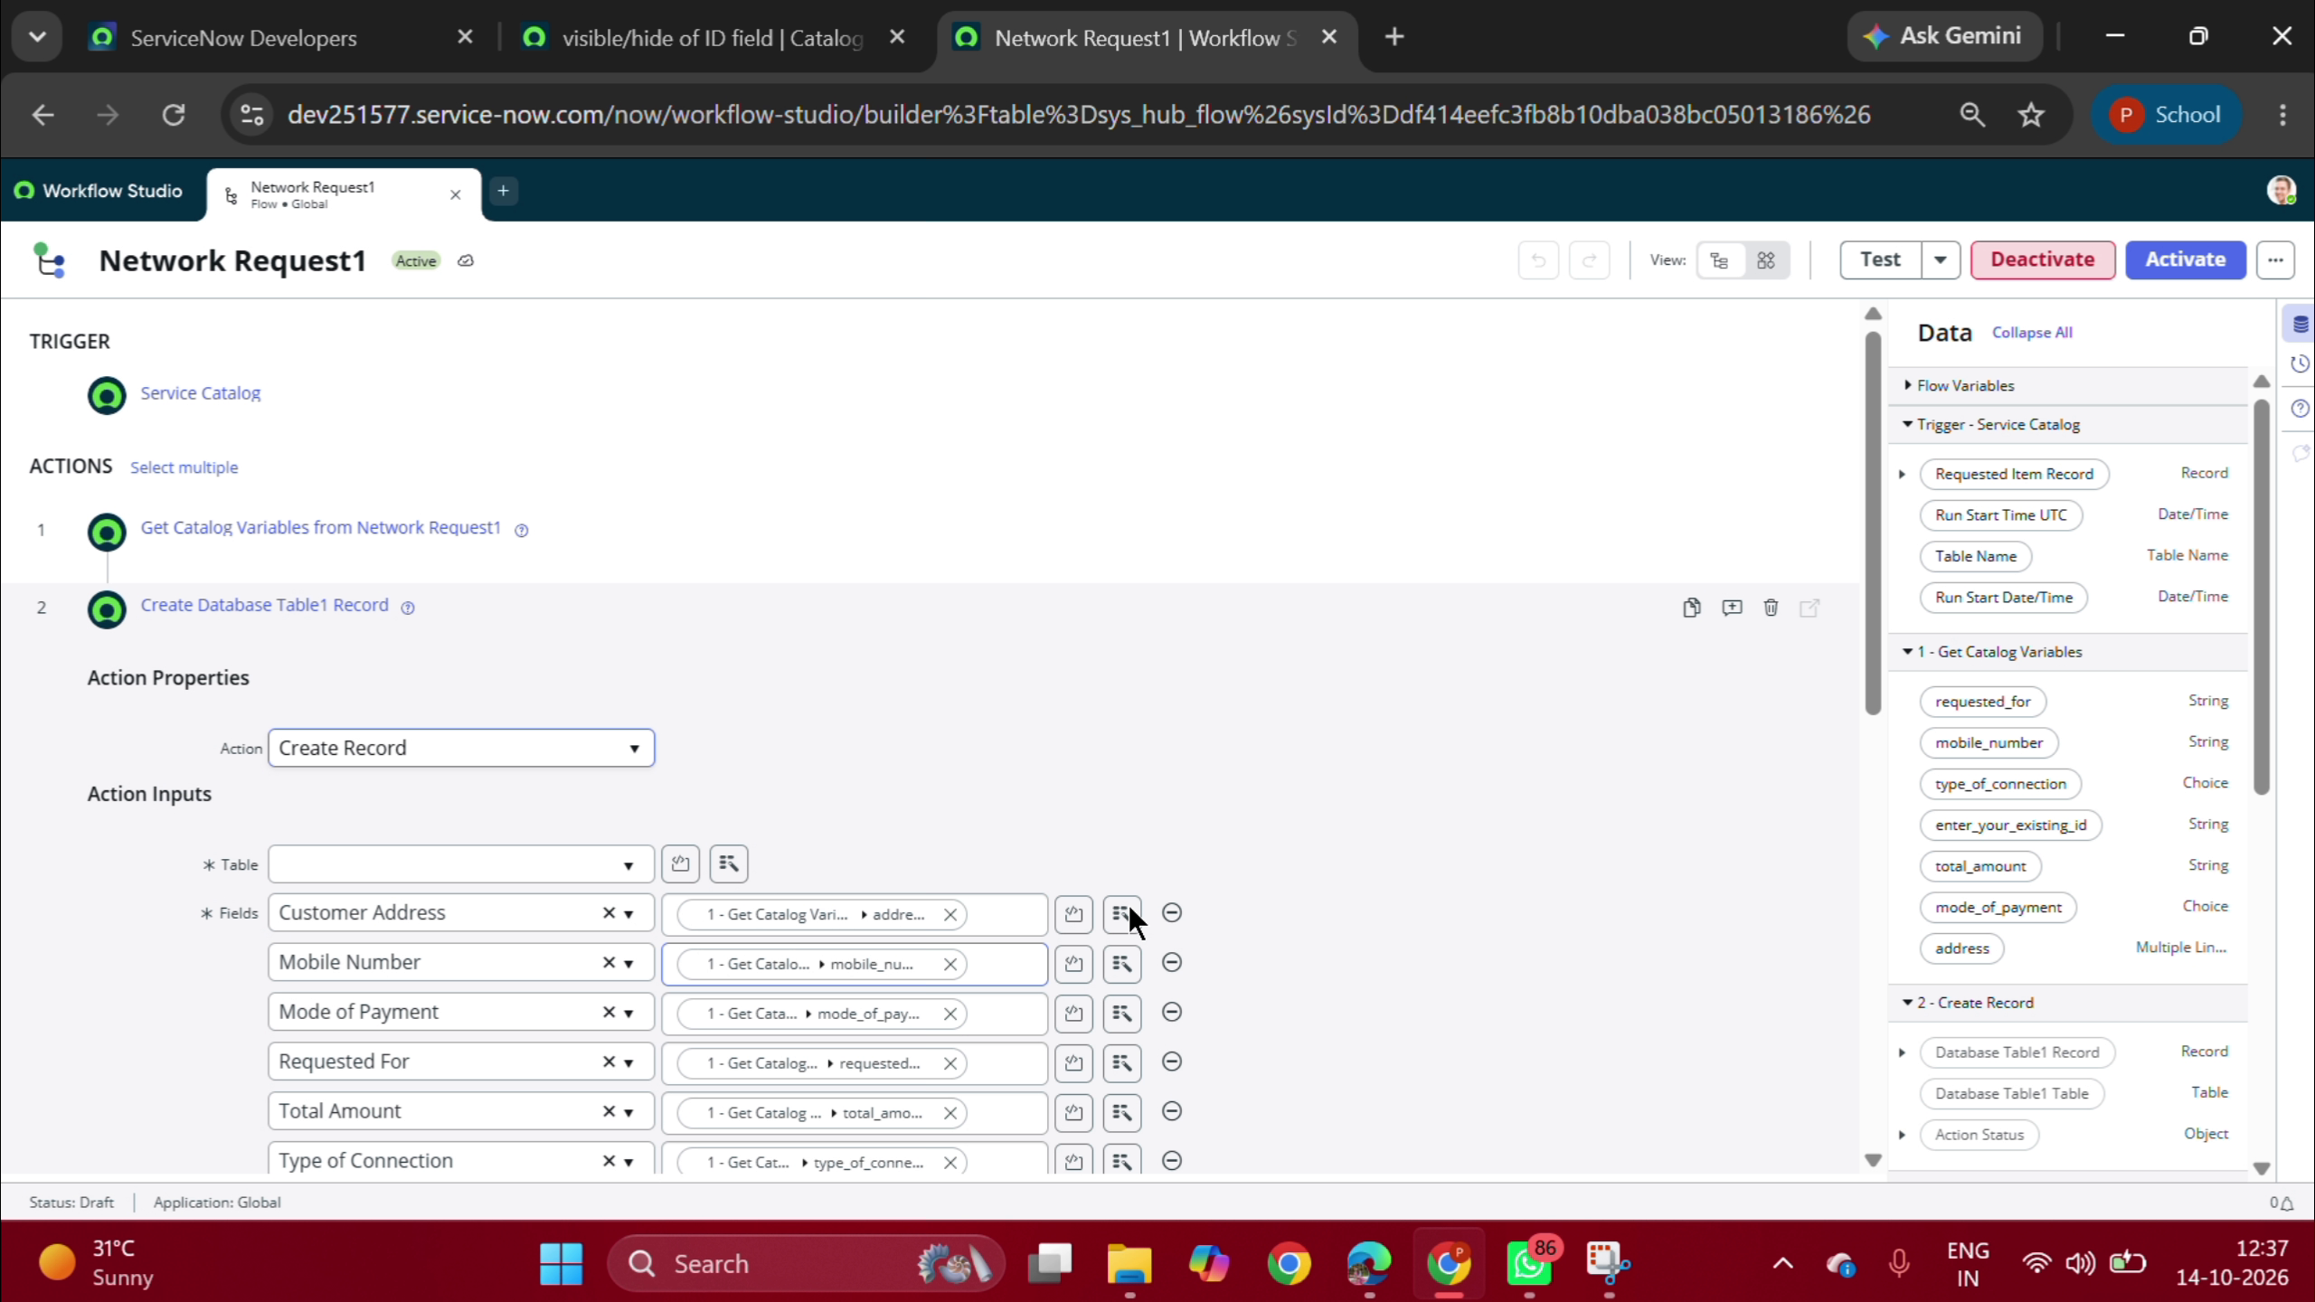
Figure 7.5: Workflow Studio / Flow Designer Flow 'Network Request1'
Shows Service Catalog trigger, 'Get Catalog Variables', and 'Create Record' action mapping data pills to u_database_table1.

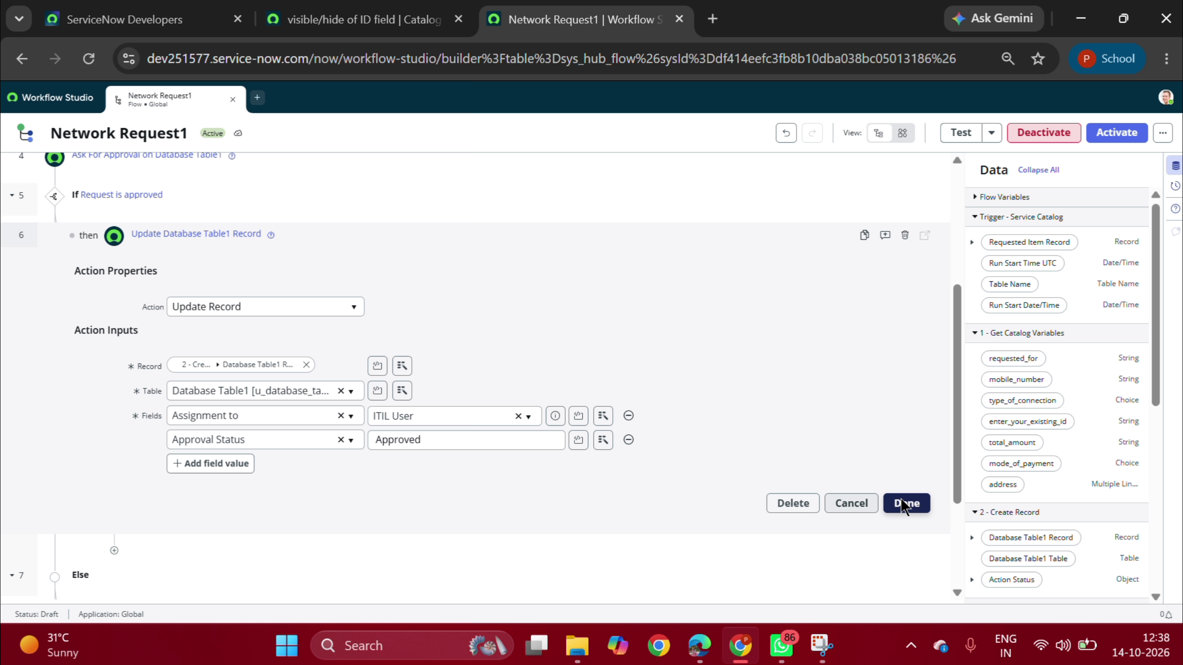
Figure 7.6: Flow Designer Approval & Record Update Actions
Shows Action 4 'Ask for Approval', 'If Request is approved' branch, and Action 6 'Update Record' setting status to 'Approved'.

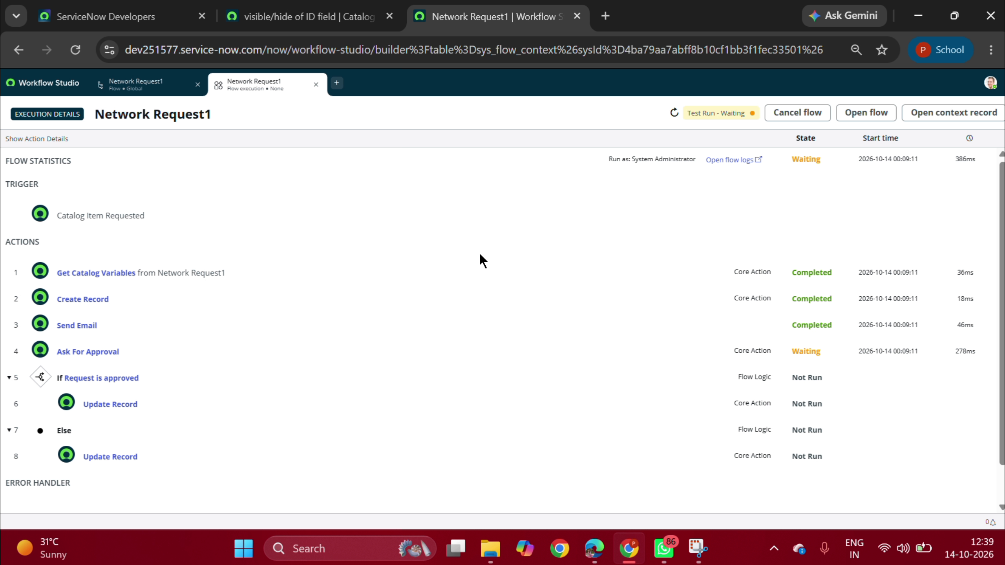
Figure 7.7: Live Flow Execution Context with Completed Steps
Execution verification showing Get Catalog Variables (36ms), Create Record (18ms), and Send Email (46ms) completed with green checkmarks.

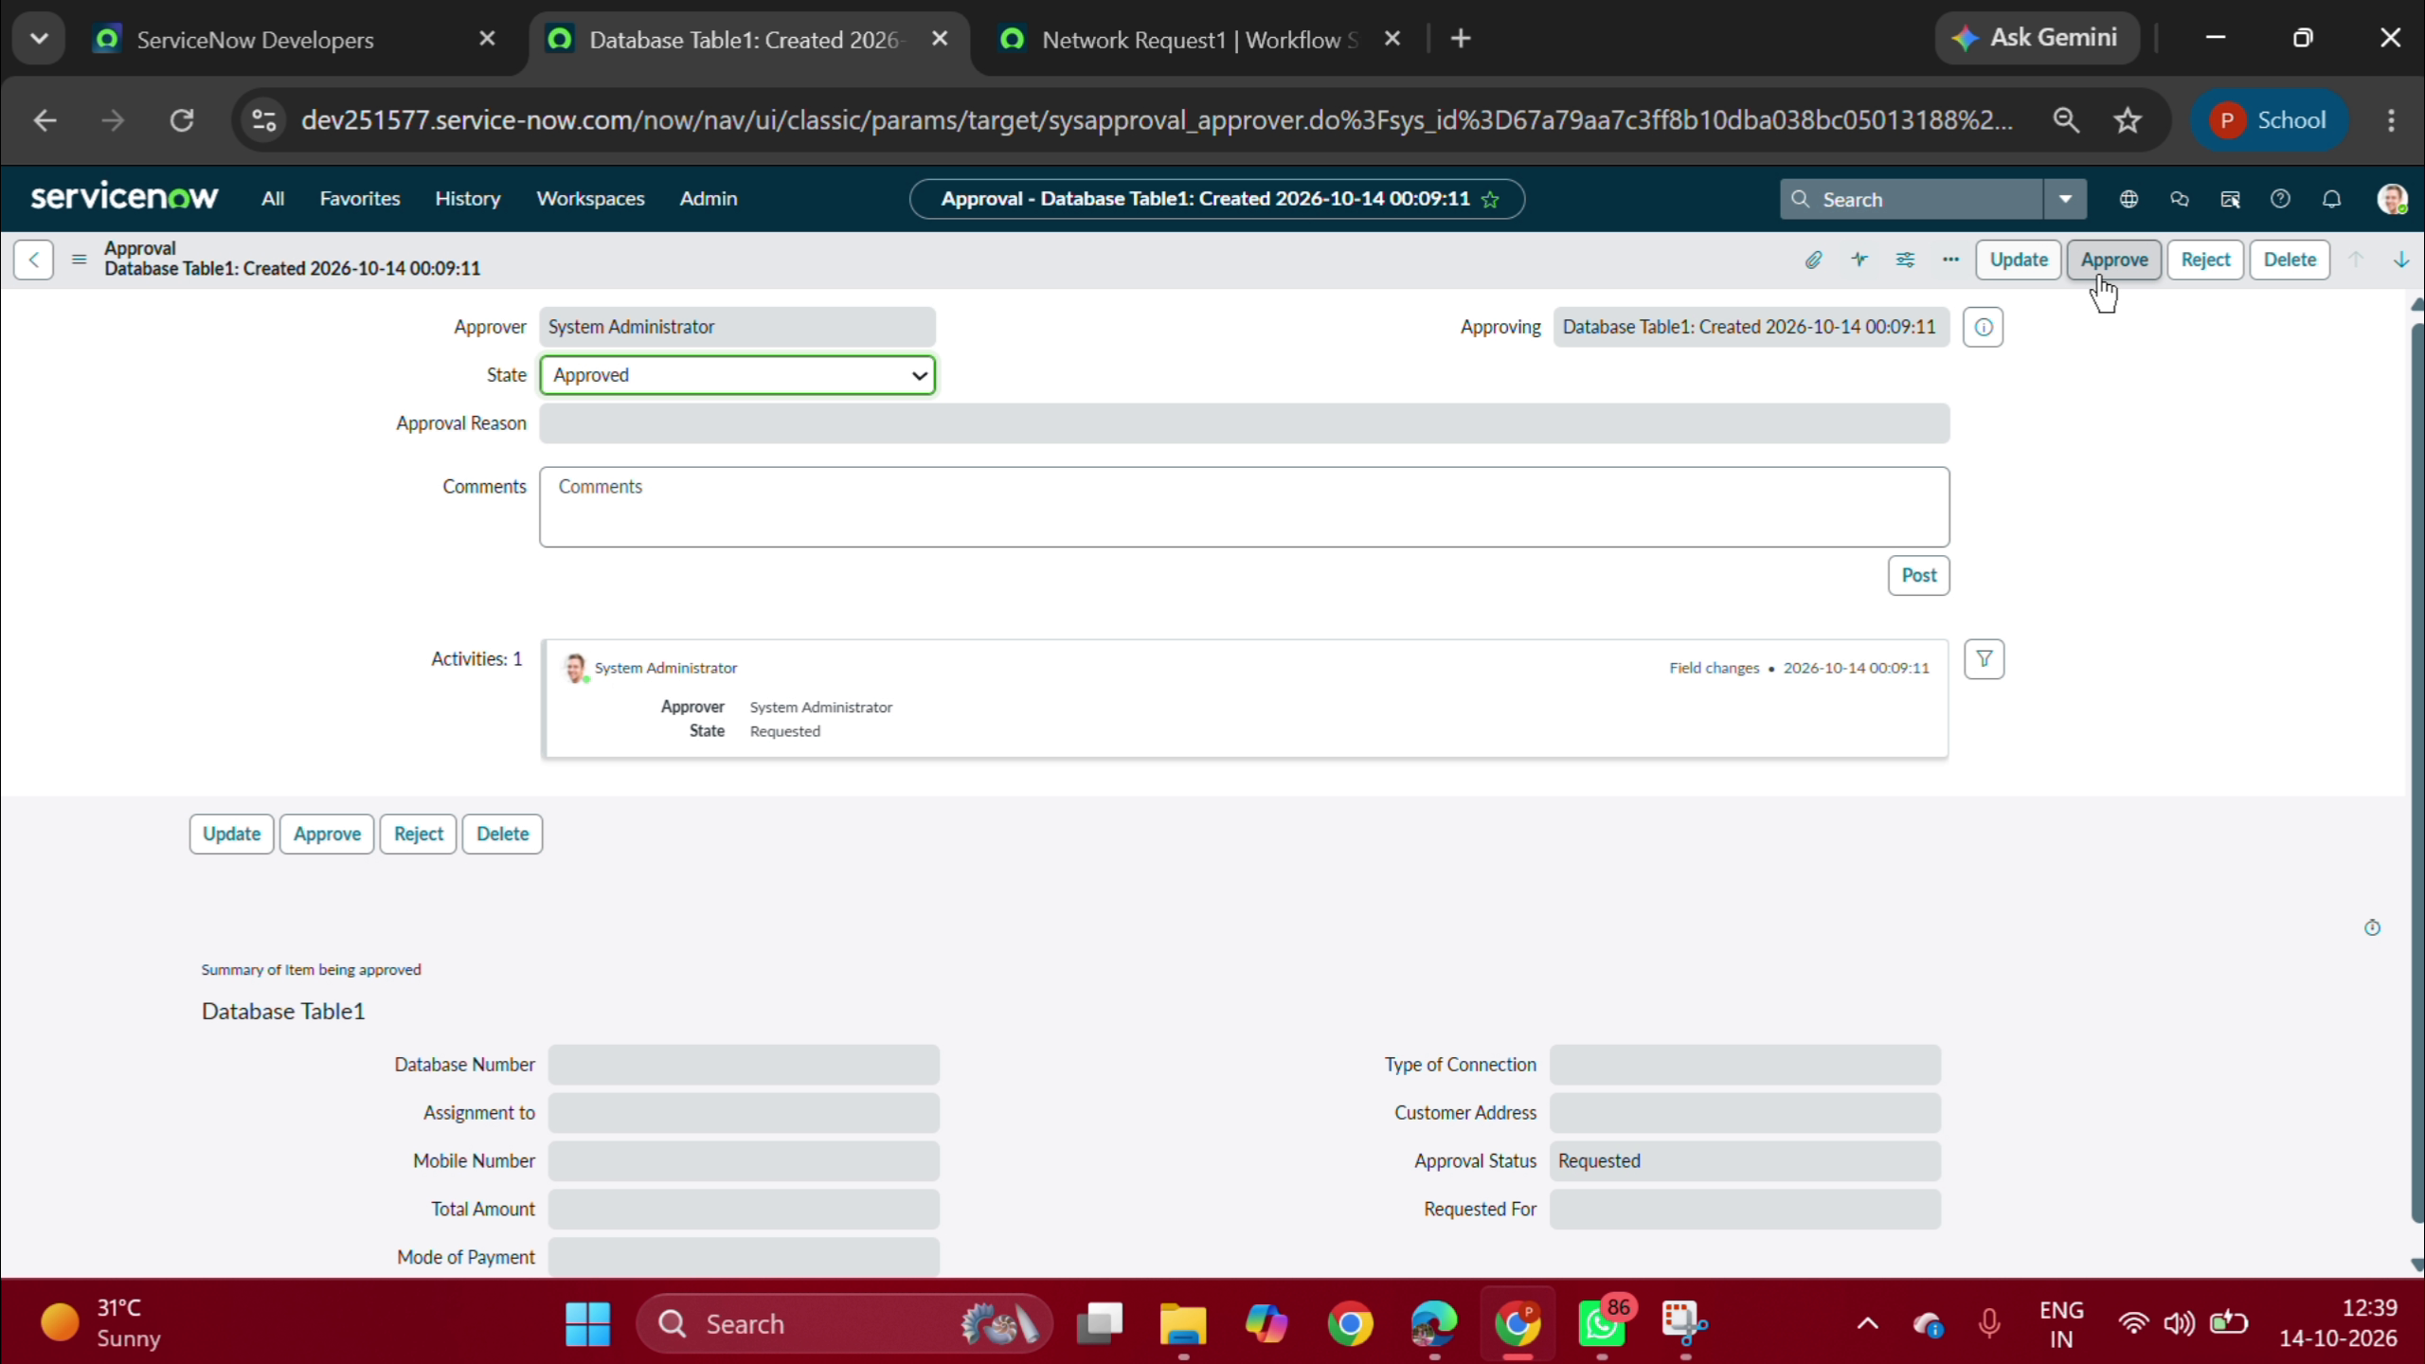
Figure 7.8: Approval Record on sysapproval_approver Table
Shows live approval record for System Administrator with State = 'Requested' and summary of item being approved.

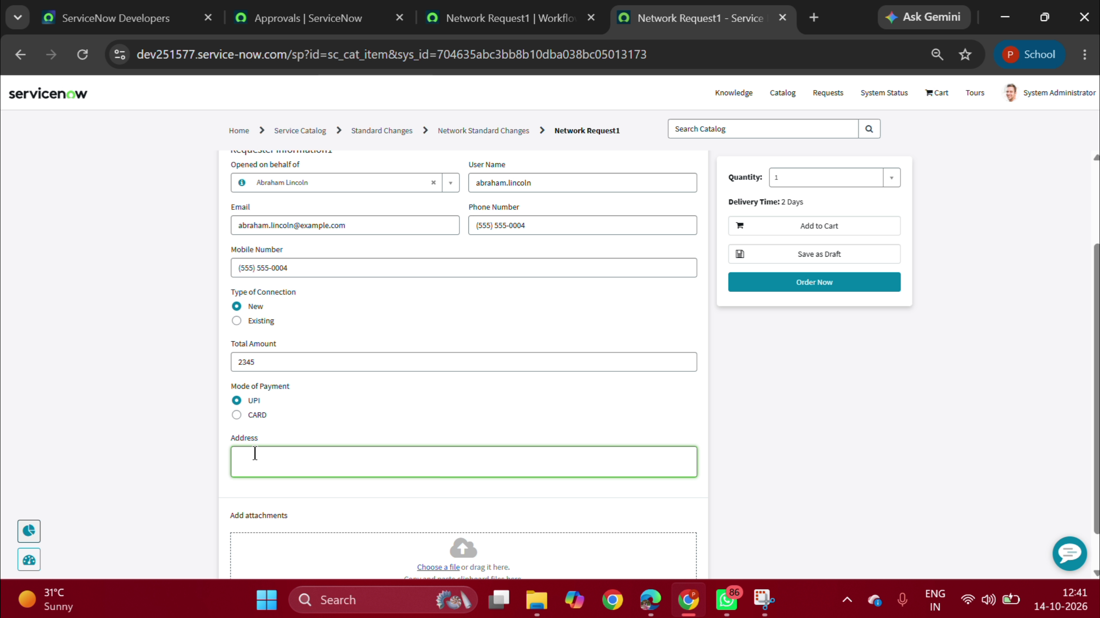
Figure 7.9: Service Portal (/sp) Request Intake Form Submitted by Abraham Lincoln
End-user portal form view showing populated fields for connection, contact, amount (2345), and address.

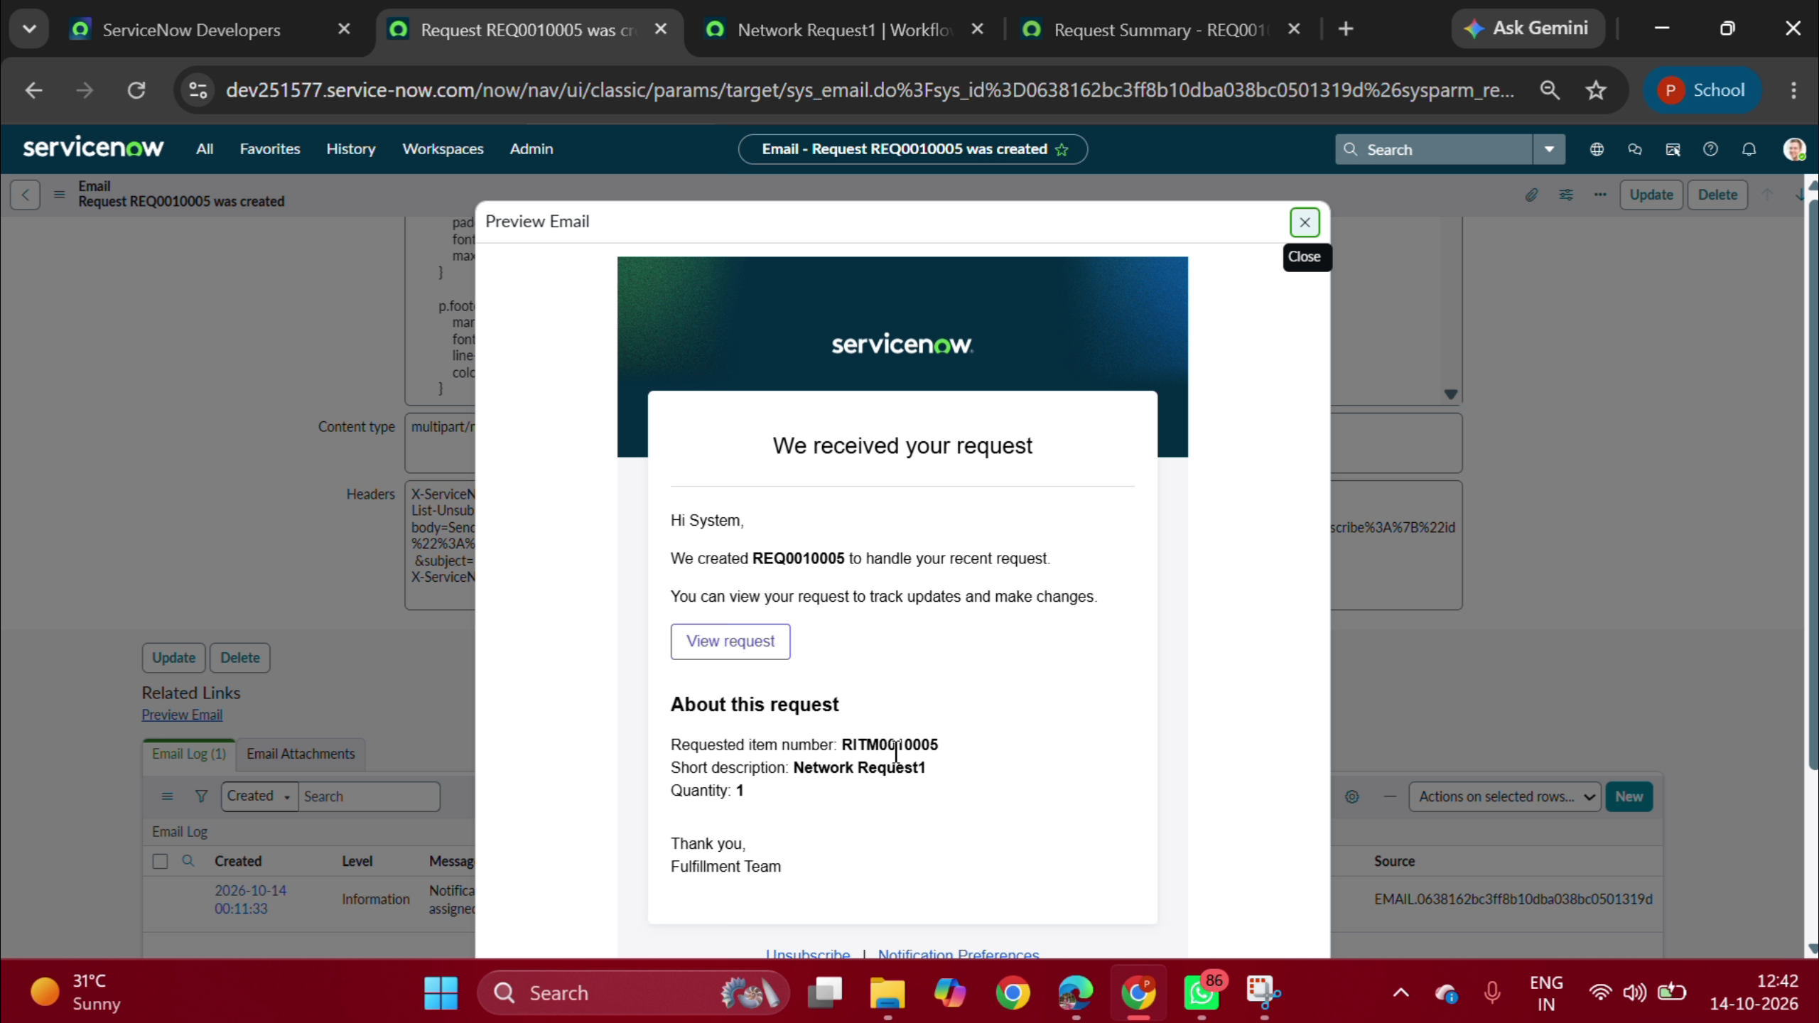
Figure 7.10: Automated Email Notification Preview ('Request REQ0010005 was created')
HTML email preview generated by ServiceNow informing the user that request REQ0010005 has been received.

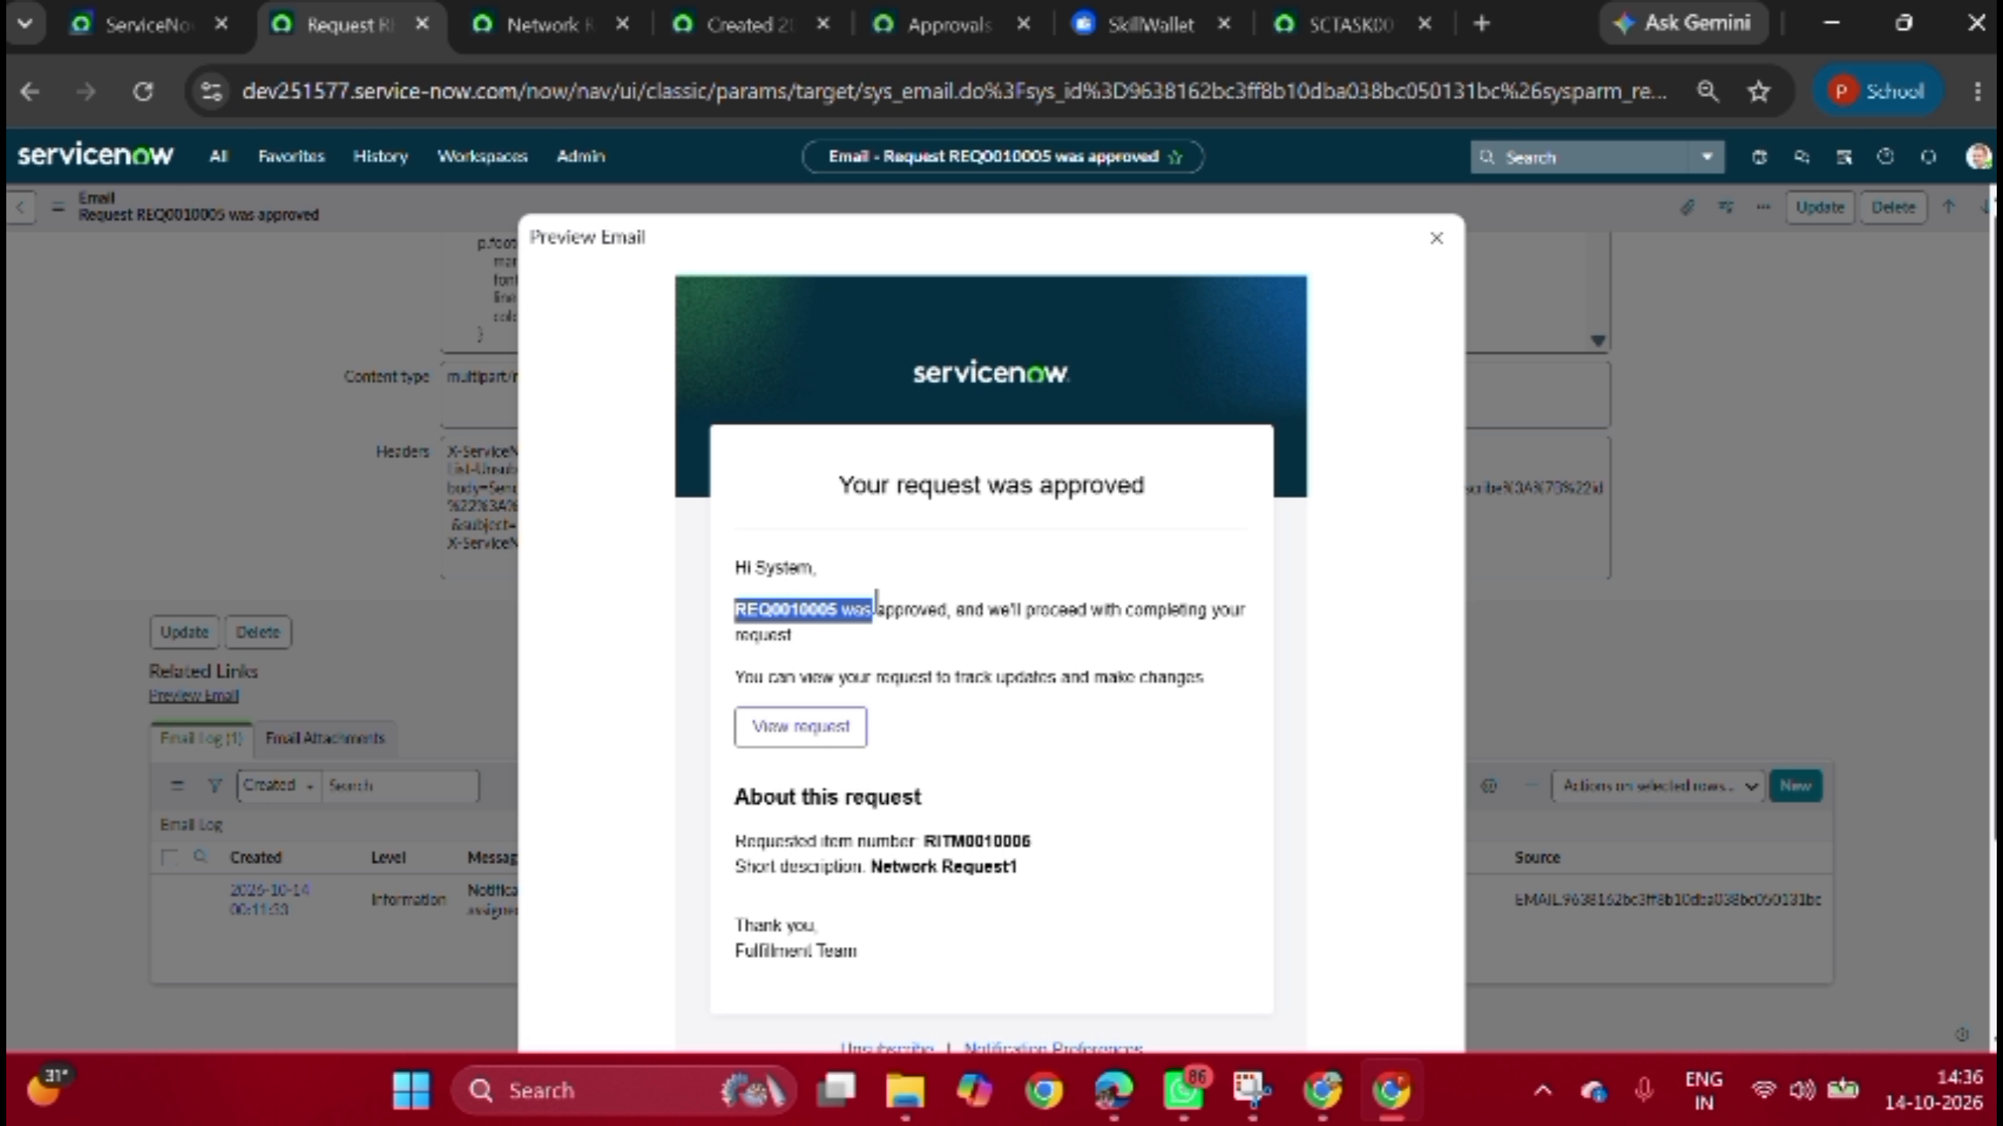
Figure 7.11: Automated Approval Confirmation Email ('Request REQ0010005 was approved')
HTML email preview confirming managerial approval of REQ0010005 and initiation of network provisioning.

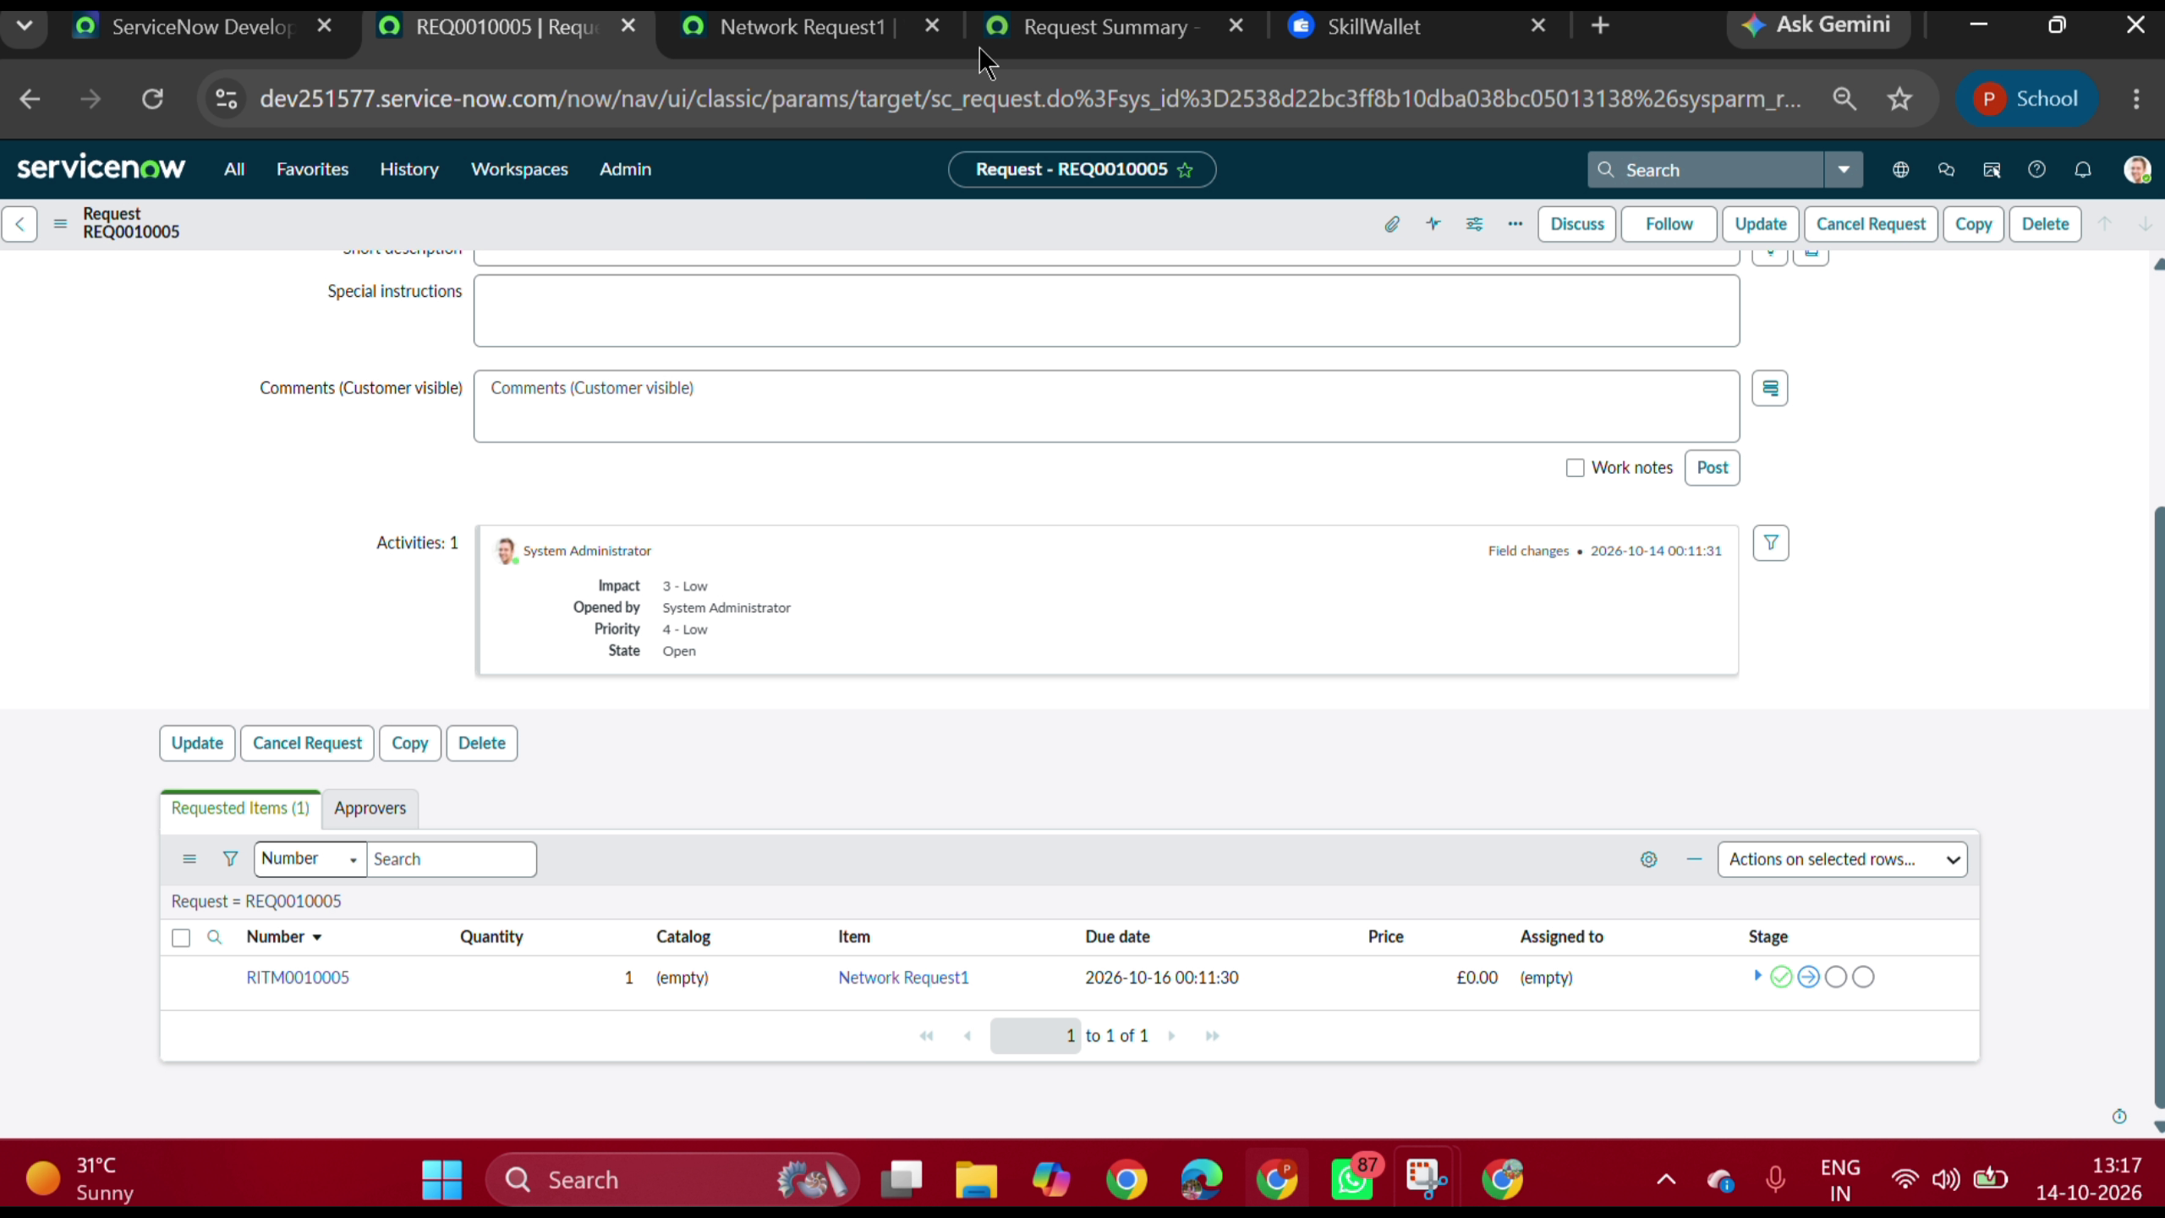
Figure 7.12: Request Detail Record (sc_request REQ0010005)
ServiceNow backend view of REQ0010005 and requested item RITM0010005 showing 'In Progress' stage.

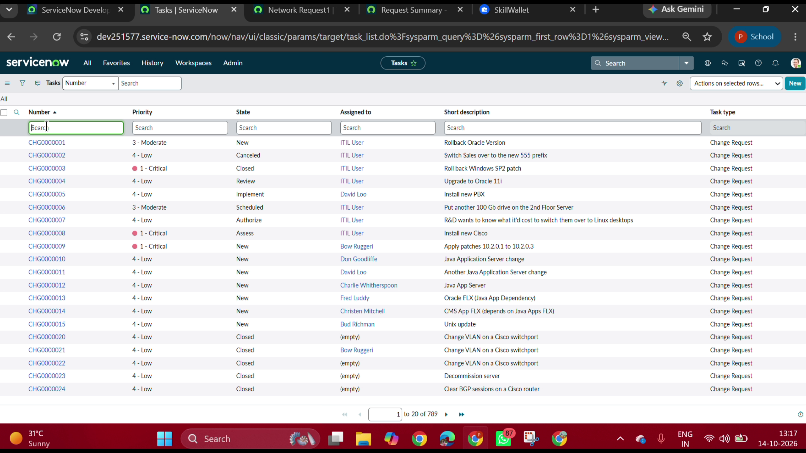
Figure 7.13: Fulfillment Tasks List (sc_task)
Fulfillment queue showing assigned task for REQ0010005 ready for network engineering execution.
8. ADVANTAGES AND DISADVANTAGES
Advantages: 100% automated self-service intake, dynamic form policy validation, dedicated custom table persistence, instant approval routing, automated email updates, and full audit traceability.
Disadvantages / Current Limitations: Sub-production PDI dormancy, and physical network configuration simulated via catalog tasks.
9. CONCLUSION
The project successfully implements an end-to-end Automated Network Request Management System on ServiceNow. The 100% UAT pass rate and live demonstration confirm operational readiness and adherence to enterprise ITIL standards.
10. FUTURE SCOPE
Direct hardware API integration (Cisco/Meraki), ServiceNow Virtual Agent chatbot intake via Teams/Slack, and interactive SLA dashboards via Performance Analytics.
11. APPENDIX
1. Project Links:
• GitHub: https://github.com/poojareddy24817/automated-network-request-management-servicenow
• Demo Video: https://drive.google.com/file/d/1BnriywWde1DKvn6q077Kuw0jLV53ShrK/view?usp=drivesdk
• Instance: https://dev251577.service-now.com
2. Custom Table Dictionary (u_database_table1):
• u_database_number, u_requested_for, u_mobile_number, u_type_of_connection, u_total_amount, u_mode_of_payment, u_customer_address, u_approval_status, u_assignment_to.

